ARRIVAL NOTICE
VESSEL: VOYAGE: ETA KOPER:
BILL OF LADING NO: CNT.

Empty containers should be returned clean and not damaged. Prior to repositioning on Luka Koper d.d. depo, containers are checked by responsible. If any damage or if container needs to be cleaned the cost will be charged to whom the container was released.
The responsible party for checking, repairing and cleaning the containers is Luka Koper d.d. If not requested no photos will be taken of containers. The only proof of damage or need of cleaning is the report filed by Luka Koper d.d. responsible. If photos are requested this will be charged 10 €/photo plus 30 € container repositioning.
If there will be any case of complain this should be solved with responsible for checking.
IMPORT DEMURRAGE & DETENTION RULES from 15.5.2022 (OBD):
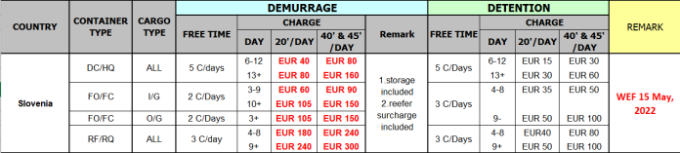
With below signature & stamp the party to who the container will be released acknowledges all terms and conditions in this arrival notice.
Date: signature & stamp
--------------------

